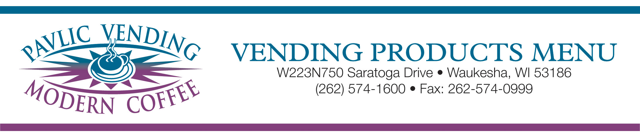

Bagged Snacks

Lay’s Potato Chips
Lay’s S.C. & Onion
Ruffles
Cheddar & SourCream Ruffles
Fritos
Frito Chili Cheese
Crunchy Cheetos
Flaming Hot Cheetos
Nacho Cheese Doritos
Cool Ranch Doritos
Sun Chips
Snyder Mini Pretzels*
Snyder Pretzel Nibblers*
Snyder Specials Pretzels*
Rold Gold Pretzels*
Bugels
TGIF Tato Skins*
Animal / Elfin Crackers*
Cheddar Cheese-Its
Wheat Thins*
Krunchers BBQ Chips
Krunchers Jalapeno Chips
Pepperidge Farm Goldfish*
Baked Lays*
Baked Ruffles*
Baked Doritos*
Baked Lays Parm. & Herb*
Wheat Thins-Veggie*
Ritz Toasted Chips
Pork Skins
Cheddar Cheese Popcorn

Premium Snacks

Gardetto’s Snackens
Chex Party Mix*
Cajun Spicy Nut Mix
Munchies Snack Mix
Salsitas
Kar’s Nut & Yogurt Mix
Kar’s Trail Mix
Kar’s Energy Trail Mix
Microwave Popcorn
Famous Amos
Kellogg’s Rice Krispy Treats*
Keebler Fudge Stripe Cookies
Salted in Shell Peanuts
Snyder Cheddar Pretzel Pieces
Knots Raspberry Cookies
Fruit Snacks*

GrandMa’s Cookies

Peanut Butter
Chocolate Chip
Oatmeal Raisin

Premium Candy Menu

Hershey’s

Twizzlers*
Hershey’s Almond
Kit Kat-Extra Crispy
Reese’s Peanut Butter Cups
Twizzler Nibs*
Whatchamacallit
Jolly Rancher Fruit Chews

Nestle’

Butterfinger
Baby Ruth
Nestle Crunch

M&M Mars

Milky Way
Milky Way Caramel
Caramel Twix
Peanut Butter Twix
Snickers
3 Musketeers
3 Musketeers Gen Max Brownie Bars*
M&M’s Plain
M&M’s Peanut
Skittles*
Starburst*
Munch Bar
Marathon Energy Bar

Miscellaneous

Salted Nut Roll
Mike & Ike*
Sweedish Fish*
Sour Patch Kids*

“Value” Candy Menu

Planters Peanuts*
Planters Dry Roasted Peanuts*
Corn Nuts
Salted Cashews*
Salted Almonds*
Sunflower Seeds*
Raisins*
Keebler Club & Cheddar
Keebler Cheese & Cheddar Crackers
Nature’s Vallley Granola *
Peanut Butter
Oats & Honey
Sweet & Salty
Strawberry Yogurt
Kellogg’s Nutri-Grain Bars*
Blueberry
Strawberry
Apple
Snackwells Vanilla Cookie*
General Mills Fiber One Bars*
Quaker Chewy Gran Bar*
Newtons Fruit Crisps*
Kellogg’s Fiber Plus Bar
Oreo’s
Swiss Cream Cookies
Twin Beef Sticks*
Beef & Cheese Sticks*

Bakery Menu

Hostess

Twinkies
Chocolate Cup Cakes
Golden Cup Cakes
Suzy Q’s
HoHo’s
Ding Dongs
Honey Buns
Apple Pie
Cherry Pie
Powdered Gems
Chocolate Gems
Cinnamon Rolls

Dolly Madison

White Zingers
Chocolate Zingers
Raspberry Zingers
Dunkin Stix
Cinn. Swirl Coffee Cake
Crunch Gems

Cloverhill Bakery

Cheese Danish
Big Texas Danish
Butterhorn Danish
Butter Crunch Danish
Apple Danish
Strawberry Chees Claw
Dbl. Chocolate Donuts
Honey Buns
Blueberry Blasters
Pound Cake

Kellogg’s Pop Tarts*
Duplex Cookies
Lemon Cream Sandwich Cookies
Grandma’s Vanilla Bits Cookies

* Indicates low fat, no fat, low carb. or “Better For You” items

Please Note: Due to seasonal availability and menu rotation, not all items are available at all times.

