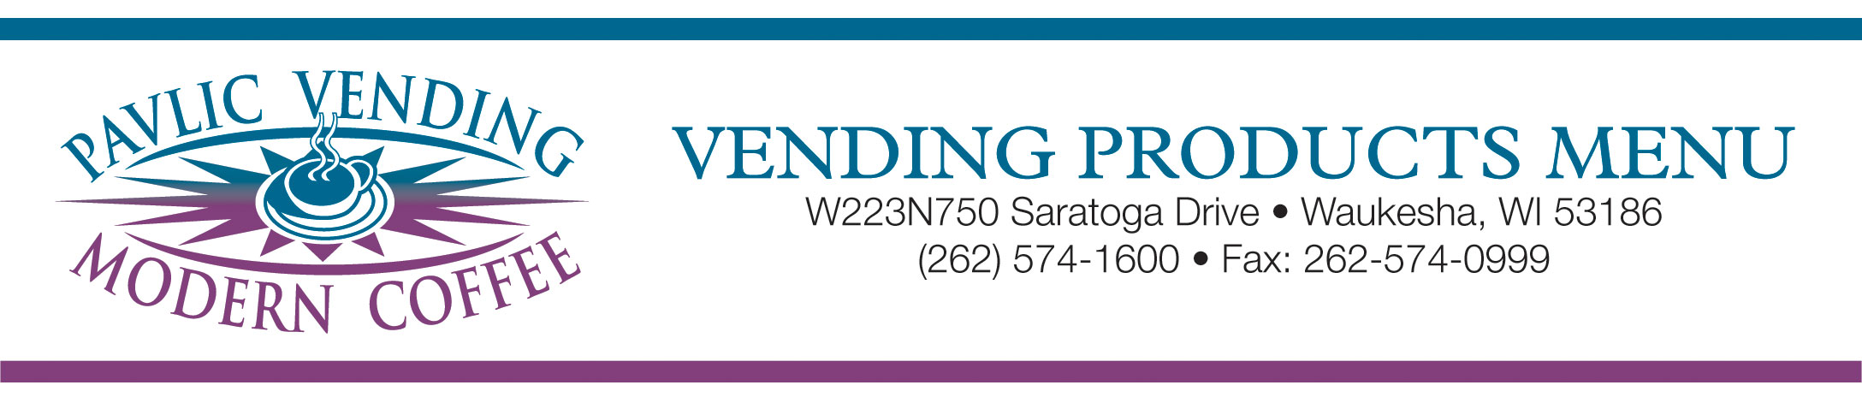

Soft Drinks – 20 oz. Bottles

Pepsi Products

Pepsi
Diet Pepsi
Mountain Dew
Diet Mountain Dew
Mt. Dew Code Red
Mug Root Beer
Hawaiian Punch
Lipton Iced Tea
Lipton Green Tea
Lipton Diet Green Tea
Lipton Raspberry White Tea
Lipton Half n Half
Tropicana Strawberry Mellon
Aquafina Water
Aquafina Splash Grape
Aquafina Splash Berry
Aquafina Splash Lemon
Aquafina Splash Raspberry
Orange Crush
Grape Crush
Sierra Mist

Coke Products

Classic Coke
Diet Coke

7-Up Products

7-Up
Diet 7-Up
Dr. Pepper
Diet Dr. Pepper
Diet Rite
Squirt
Country Time Lemonade
Country Time Pink Lemonade

Black Bear Sodas

Black Cherry
Orange
Grape
Root Beer
Cream Soda
Blue Raspberry
Cherry

Soft Drinks – 12 oz. Cans

Pepsi Products

Pepsi
Diet Pepsi
Cherry Pepsi
Mountain Dew
Diet Mountain Dew
Caffeine Free Diet Pepsi
Mug Root Beer
Diet Mug Root Beer
Hawaiian Punch
Lipton Iced Tea
Lipton Diet Iced Tea
Tropicana OrangeAde
Diet Cherry Pepsi
Sierra Mist
Diet Sierra Mist

Coke Products

Classic Coke
Coke Zero
Diet Coke
Diet Coke w/Lime
Caffeine Free Diet Coke
Cherry Coke
Sprite
Fresca

7-Up Products

7-Up
Diet 7-Up
Doctorr Pepper
Diet Doctor Pepper
C.F. Diet Doctor Pepper
Diet Rite
Squirt
Diet Squirt
A&W Root Beer
Country Time Lemonade

G. Heileman Products

Lemon LaCroix
Lime LaCroix
Berry LaCroix
Plain LaCroix

Please Note: Due to seasonal availability and menu rotation, not all items are available at all times.

Misc. & Specialty Drinks

Spring Water 20 oz.
Gatorade Fruit Punch
Riptide Rush
Lemon Lime
Rain Berry
Glacier Freeze
G2 Glacier Freeze
G2 Orange
Snapple Iced Tea
Diet Iced Tea
Fruit Punch
Kiwi Straw
Black Tea w/Lemon
Pomegranate Rasp.Red Tea
Peach Green Tea
Tropicana Twisters
Strawberry Kiwi
Tropical Fruit Fury
Arizona Green Tea
Yoo Hoo
Sunny Delight
Arnold Palmer Half & Half
Sprecher Root Beer
Sobe Life Waters
Mango Melon
Yumberry Pomegranate
Strawberry Dragonfruit
Agave Lemonade
Black Cherry Dragonfruit
Blackberry Grape
Pomegranate Cherry
Fuji Apple Pear
Glaceau Vitamin Waters
Red Bull
Monster Energy Drink
Amp Energy Drink
Venom Energy Drink
Nesquick Flavored Milk
Chocolate
Strawberry
Starbucks Frappuccino

Fruit Juices

11.5 Ounce Cans

100% Apple Juice
100% Orange Juice
100% Grape Juice
Cranberry Juice Cocktail
V-8 Juice
Fruit Punch
Pineapple Orange
Apple Cranberry
Ruby Red Grapefruit Juice

16 Ounce Bottles

100% Orange Juice
100% Apple Juice
Ruby Red Grapefruit Juice
Grape Juice Cocktail
Cranberry Cocktail

